Case Study:4 — Employee Payroll and Deduction Analysis

1. Problem Statement
Develop a Python program to calculate an employee's salary after adding allowances and subtracting deductions. Classify the employee's salary based on the net salary using conditional statements.

2. Objectives
Calculate the employee's gross salary.
Calculate deductions and net salary.
Classify the salary based on the net amount.

3. Assumptions
Basic salary, allowances, and deductions are non-negative.
Gross salary = Basic Salary + Allowances.
Net salary = Gross Salary − Deductions.
Salary classification thresholds are defined by the programmer.

4. Algorithm
- Start.
- Read the employee's name, basic salary, allowances, and deductions.
- Calculate the gross salary.
- Subtract deductions to calculate the net salary.
- Use if-elif-else to classify the salary.
- Display the gross salary, deductions, net salary, and category.
- Stop.

5. Flowchart

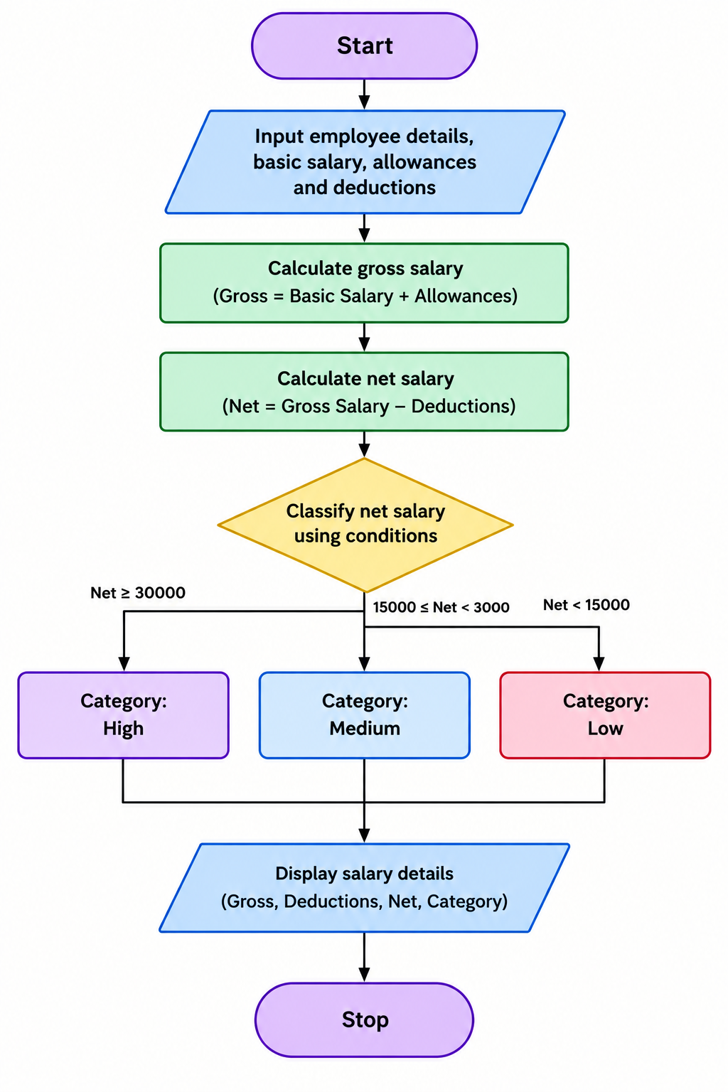

6. Pseudocode
START
INPUT name, basic_salary, allowances, deductions

gross = basic_salary + allowances
net = gross - deductions

IF net >= 30000
category = "High"
ELSE IF net >= 15000
category = "Medium"
ELSE
category = "Low"
END IF

DISPLAY gross, deductions, net, category
STOP

7. Test Cases
Basic salary | Allowances | Deductions | Net salary | Expected category
₹25,000 | ₹5,000 | ₹2,000 | ₹28,000 | Medium
₹35,000 | ₹5,000 | ₹3,000 | ₹37,000 | High
₹12,000 | ₹2,000 | ₹1,000 | ₹13,000 | Low

8.Output

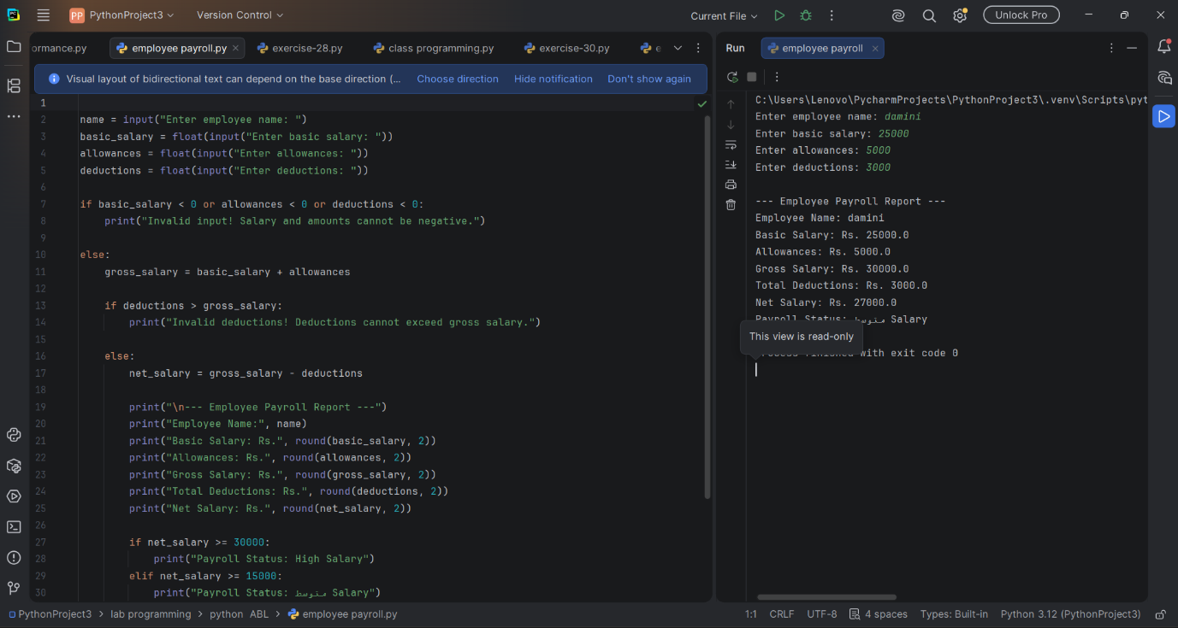

9. Conclusion
The program calculates gross salary, deductions, and net salary, then classifies the employee's salary using conditional statements. It simplifies payroll calculations and helps analyze employee salary categories.

